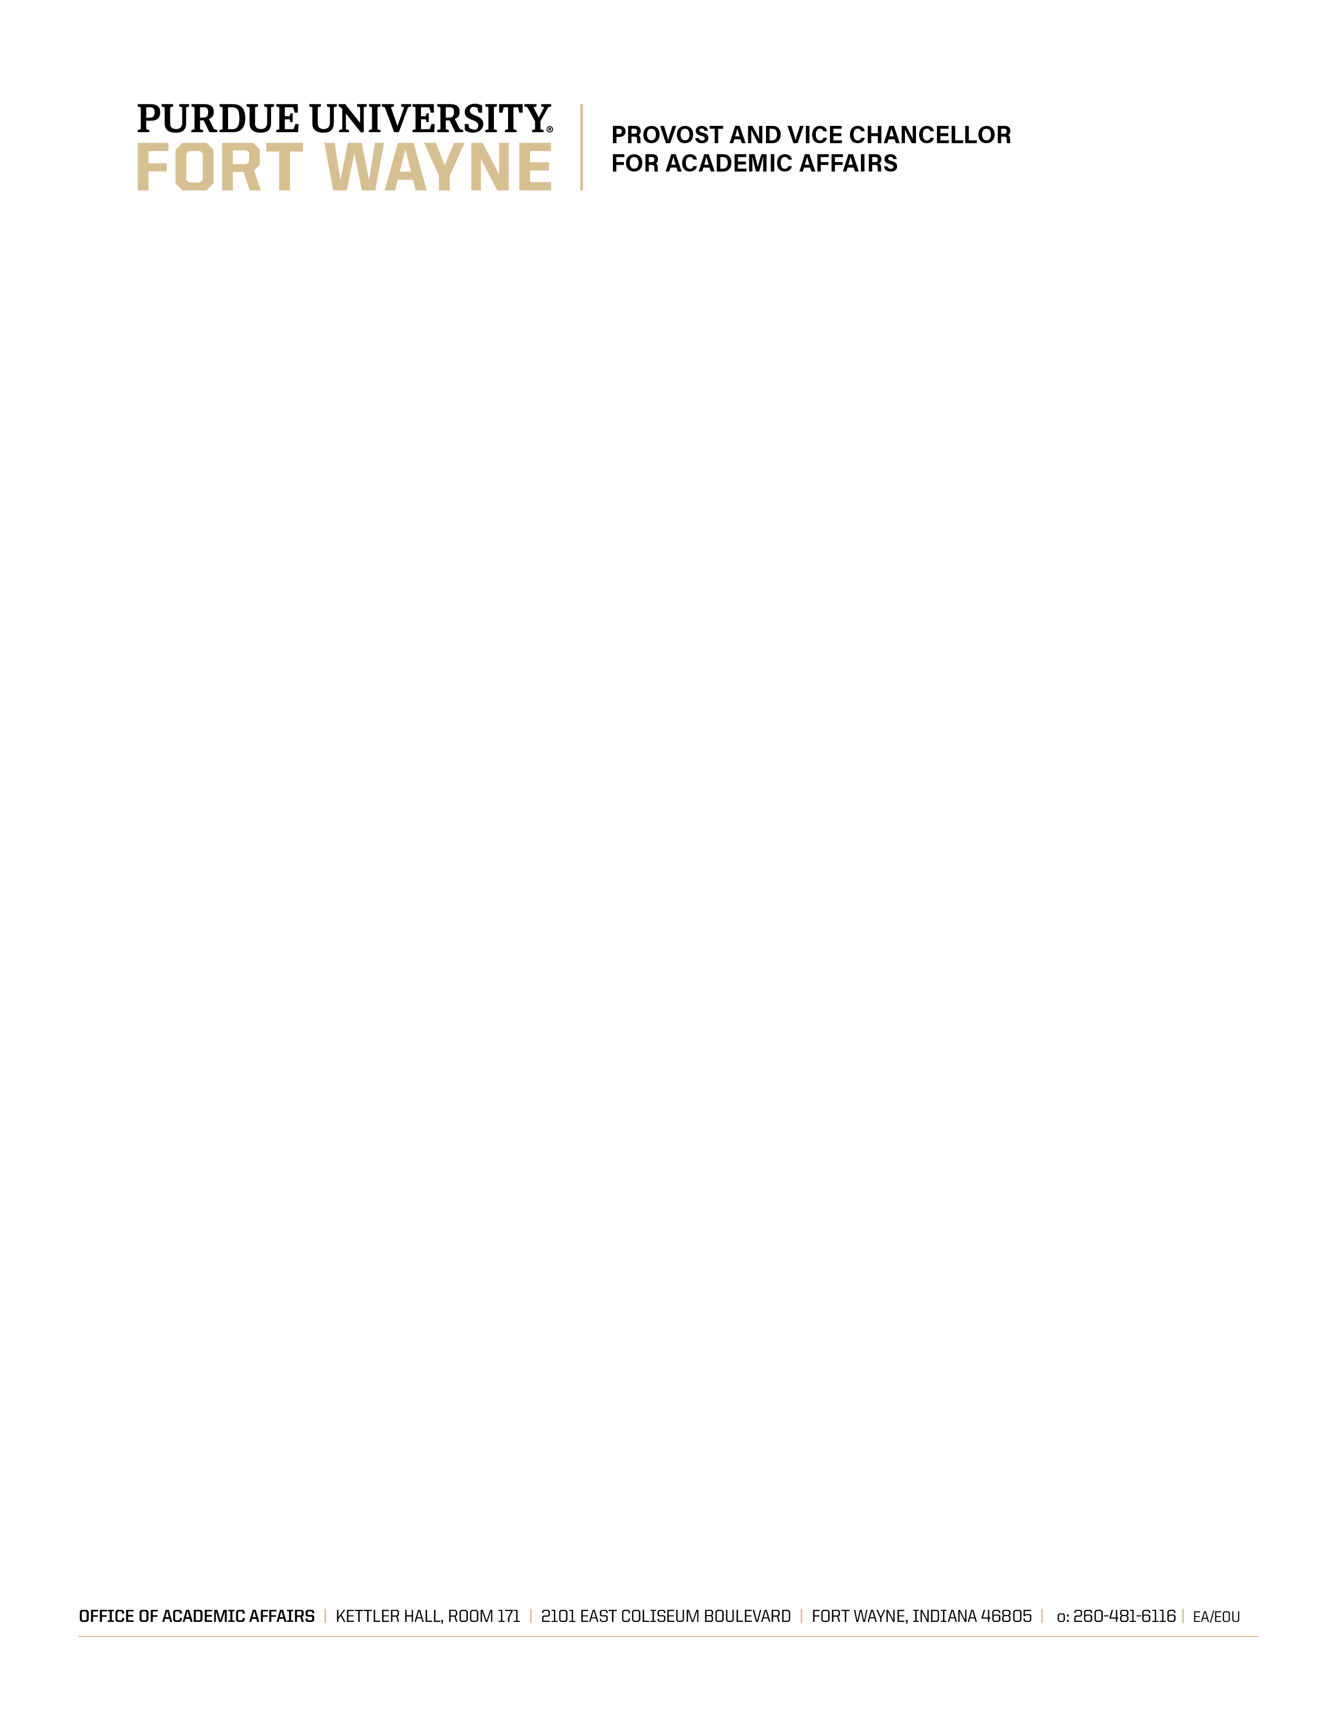

OFFICE OF ACADEMIC AFFAIRS MEMORANDUM 16-3
Revised April 7, 2017
Page 1
Framework for Program Review

Three reports (annual departmental reports, annual assessment reports, and the institutional profile) should be carefully analyzed and reflection provided. Feedback received from the annual departmental report and assessment reports should be referenced in your report. The program review document (excluding appendices) should not exceed 25 pages.

Program Context: Provide information that will help in understanding the program. Potential topics include:

- History of the program
- Program demand/niches (e.g., industry/community need, service courses, Gen Ed offerings)
- Accreditations & licensures
- Curriculum (e.g., professional standards, advisory boards, disciplinary trends)
- Major program changes since last review

Departmental Profile: Using reports provided by Institutional Research, review the following information and trends:

- number of degrees awarded
- credit hours generated
- number of majors and faculty
- resources/budget
- recruitment and retention rates
- graduation rates
- Analyze the trends and the impact: how do these align with national and/or regional trends?

Strategic Direction: Using the departmental USAP report(s), reflect on and answer the following questions:

- How have your goals aligned and supported the mission of the department, college/school, and university?
- How have they aligned with the strategic direction of the department, college/school, and university?
- What goals have been achieved? (Provide evidence (e.g., metrics used) to support your conclusions.)

OFFICE OF ACADEMIC AFFAIRS MEMORANDUM 16-3
Revised April 7, 2017
Page 2

- Have you received additional resources to assist in accomplishing unit goals? If so, how have these resources been used/allocated? What impact did they have on reaching your goals?
- What needs have you identified that have not been met? How has that influenced your program?

Student Learning: Using the annual assessment report(s), reflect on and answer the following questions:

- What are your program’s learning outcomes?
- Are the program learning outcomes aligned with discipline practices and with the Baccalaureate Framework?
- Are program learning outcomes current, relevant, and measurable?
- Are the assessment data adequate? Are they aligned with the learning outcomes? Provide specific examples.
- What has been learned from an examination of the data? Provide specific examples.
- Describe how your assessment data are being used to improve student learning and achievement.
- Based on your assessment findings, what additional resources/facilities (departmental or campus) are needed to improve learning?

Faculty: Using appropriate departmental reports, address the following:

- Assess all faculty (all ranks and Limited Term Lecturers) in terms of qualifications: teaching; research, scholarship and creative endeavor; and service/engagement. How does this staffing impact the delivery of the program?
- Assess department, college/school, and campus-level support for all faculty development (e.g., mentoring, promotion and tenure criteria and processes, governance issues).

Students and Alumni: Highlight significant student and alumni accomplishments.

Other comments: Please discuss any other topics not adequately covered in the sections listed above (e.g., support to other academic units, staffing, diversity initiatives, outreach activities).

Year Improvement Plan
Based on this review, please provide a 5-year improvement/maintenance plan. Include in your plan: strengths, areas needing improvement, challenges/concerns, and recommendations/plans of action (include resources needed).

OFFICE OF ACADEMIC AFFAIRS MEMORANDUM 16-3
Revised April 7, 2017
Page 3
APPENDICES
The following items should be included as appendices of the review along with any other pertinent materials.

- Unit assessment reports of student learning and feedback on these reports (from the time of the last program review to the present)
- Institutional Research (IR) data (the most recent profile)
- Unit annual reports (from the time of the last program review to the present) The unit annual report shall consist of:
- Unit Goals/Progress/Accomplishments
- Program Viability and Enrollment Management metrics, discussion, and planning
- Faculty, student and staff significant accomplishments in the areas of
  - Scholarship and creative endeavor
  - Teaching and learning
  - Service
  - Above to include items not included in USAP goals
  - Alumni information such as
  - Survey information
  - Career accomplishments
  - Employment
  - Professional and graduate school enrollment
  - Resource allocation recommendations

Once completed, the following should also be included:
- Peer review team’s report

_____________________________
Carl N. Drummond
Vice Chancellor for Academic Affairs

